DEALS TO OAHU

The beautiful island of Oahu is also known as the “gathering place” due to its high population of locals and tourists year-round. It is the third-largest Hawaiian island with may incredible things to see and do. Book a trip to Oahu via Honolulu International Airport on Virgin America. Fly in style with food, drinks, and movies on-demand.

(MARKET IMAGE HERE)

Find Deals From These Cities

INSERT FARE GRID FROM / TO Version (if available!)



Top Things To Do in Oahu

Below are a few of our favorites things to check out when visiting Oahu.

* Relax at Waikiki Beach, where the water is warm and the sand is soft. Of course, there are plenty of water activities for those seeking more adventure. For a happening night scene, head out to the Waikiki strip.
* Take the drive up to the North Shore. It takes less than 30 minutes to reach the peaceful countryside and its secluded beaches and charming mom-and-pop stores. On the drive, relish the picturesque views, and stop for a tasty treat at one of the fruit stands or snack trucks along the edges of the highway. Don’t miss Romy’s Kahuku Prawns & Shrimp for the freshest catch.
* Hike up Diamond Head for some truly jaw-dropping views.
* Visit the Dole Plantation. Exploring their Pineapple Garden Maze (named the “World’s Largest Maze” by The Guinness Book of World Records) and having their famous Dole Whip at the Plantation Grille are two must-dos while there.

Travel Tips and Resources

[Must-Dos in Oahuhttp://www.tripadvisor.com/Attractions-g29222-Activities-Oahu_Hawaii.html](http://www.tripadvisor.com/Attractions-g29222-Activities-Oahu_Hawaii.html)

[Oahu Hotelshttp://www.tripadvisor.com/Hotels-g29222_Oahu_Hawaii-Hotels.html](http://www.tripadvisor.com/Hotels-g29222_Oahu_Hawaii-Hotels.html)

[Oahu Restaurantshttp://www.tripadvisor.com/Restaurants-g29222-Oahu_Hawaii.html](http://www.tripadvisor.com/Restaurants-g29222-Oahu_Hawaii.html)

[Oahu Shopping Guidehttp://www.wheretraveler.com/oahu/oahu-shopping-guide-waikiki-and-beyond](http://www.wheretraveler.com/oahu/oahu-shopping-guide-waikiki-and-beyond)

[Oahu Nightlife and Entertainmenthttp://www.gohawaii.com/en/oahu/plan-a-trip/activities/nightlife](http://www.gohawaii.com/en/oahu/plan-a-trip/activities/nightlife)

[Oahu Travel Tipshttp://www.gohawaii.com/en/oahu/about/travel-tips/](http://www.gohawaii.com/en/oahu/about/travel-tips/)

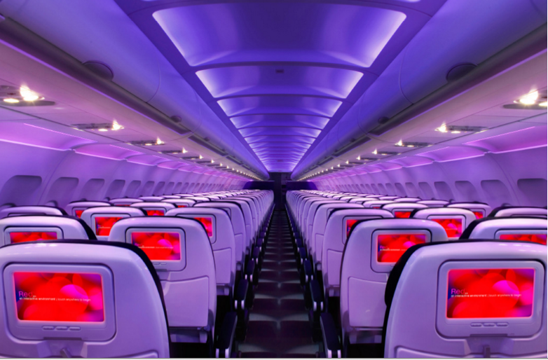

Main Cabin Main Cabin Select First Class

(add links to Cabin Class Pages)

Ready. Set. Fly.

Book your Mood-lit Ride to Oahu.

When searching for flights to Oahu, you’ll see that Oahu is served by Honolulu International Airport. To ensure your trip to Oahu starts out in the best possible way, book your flight to Honolulu with Virgin America. You’ll be greeted by our warm and friendly staff as you board your flight, and will enjoy numerous perks that make you feel right at home in the sky. The most comfortable leather seating, convenient on-demand food ordering, personal outlets and so much more. Fly with us, and experience what makes Virgin America different.

Take a Virtual Tour

Add Terms & Conditions